TEST STARTED: After loading page test from provided link.
TESTING TIME: 3 hours
Working environment:
Laptop Computer
INTEL CORE i3 2,53Ghz
MEMORY 4 GB
WINDOWS 7 Home Premium SP1
Firefox Browser 74.0 64Bits

TEST RESULTS:
BUG 1. No navigation bar for page 1 at initial load.
Priority: Medium*
Severity: Low
DESCRIPTION: There is no navigation bar below screen which appears after switiching by button to next ‘page’ (“signature’) from initial page. However after returning from page nr 2 to page number 1 (“Drag and drop files”) – navigation bar is visible and working normally.
Expected result: Navigation bar should be visible and accessible from first page also.

BUG 2. Button does not giving expected feedback - not turning to red color.
Priority: Medium*
Severity: Moderate*
DESCRIPTION: While switching from page 4 to 2 using ‘previous’ button (in displayed windows): Navigation point on navigation bar turn to red color (on page 3) signalizing that required field was not filled properly. While switching from page 2 to 1, navigation point of page 2 is filled with white color, however filed on page 2 is also marked as ‘required’.
Expected result: Navigation point on navigation bar for page 2 should turn to red color signalizing that required field was not filled properly (just like in case of other fields).

BUG 3: Information about required fields is not complete.
Priority: Low
Severity: Low
DESCRIPTION: On page 3 – information about required fields – PHONE NUMBER is suggestion to fill fields which is marked with the same description (Phone number). However is essential also to fill field AREA CODE. Also, feedback is saying ‘field is required’ but there are two fields regarding this feedback.
Expected result: Information and feedback should be properly informing which (and how many) fields must be filled properly.

BUG 4: Page 3 – No validation of input data for fields
Priority: Low
Severity: Low*
DESCRIPTION: On Page 3 is possible to put any type of input for fields with positive feedback.
Expected result: Validation for input fields.

BUG 5: Graphic issue or buttons improperly separated.
Priority: Low
Severity: Low*
DESCRIPTION: Observation and reactions of button (animated arrow for NEXT->) is suggesting there are two buttons colored by green color. There is gap and difference between fields also. Problems are marked at the picture below. Error DOES NOT occurs at page 5.
Expected result: No gap and line on graphic OR more visible and separated fields as buttons.
Attachments: SCREENSHOT

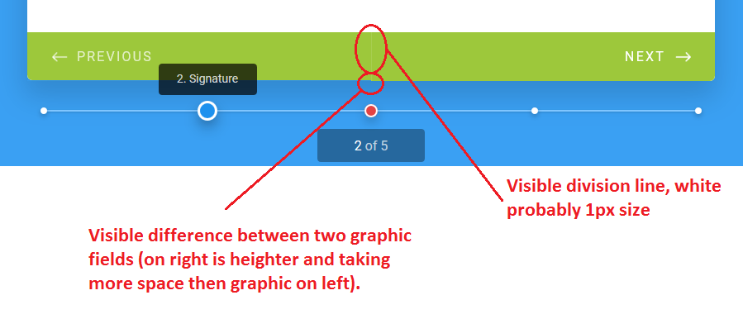

BUG 6: Navigation bar for page 1 is missing description.
Priority: Low
Severity: Low
DESCRIPTION: There is only “1.” for information. No description of this page.
Expected result: There is information for this point (page 1) at navigation bar.
Attachments: SCREENSHOT
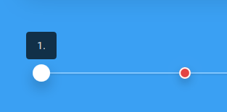

BUG 7: Wrong data size recognition in drag&drop page (1).
Priority: Low*
Severity: Low*
DESCRIPTION: File recognized by windows with size 10,6 Mb is classified as too large. File uploaded as 10,6 MB it is accepted, however real size of file is recognized by windows is 10,5 Mb. This is causing confusion for user, although is not exactly malfunction.
Expected result: Information should be underlaying fact that 10,6 MB is not equal to windows (or other) system interpretation which presents ‘general’ value of file size (lowered). Would be helpful if system would be informing user how large is file for example: File is too large: 10,621 MB.

BUG 8: Empty field in drop-down menu in page 4 (Security question).
Priority: Low*
Severity: Low*
DESCRIPTION: After displaying menu by down-arrow button there is empty clickable bar (screenshot attached, problem marked with red color). Is possible to choose it and leave question field empty.

Expected result: Drop-down menu should be properly formatted. Only planned fields should be visible and clickable.
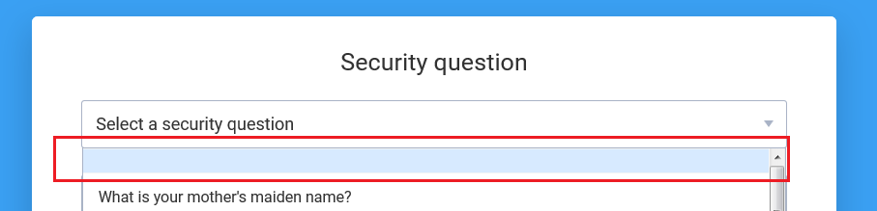

‘*’ symbol is suggesting that depends on final shape of this functionality and project expectations, priority/severity can be higher/lower.

